PREDICTING MECHANICAL STRENGTH IN POLYPROPYLENE FIBRE REINFORCED HIGH STRENGTH CONCRETE USING REGRESSION AI TECHNIQUES. SUITABLE TITLE
1.ABSTRACT:
The demand for sustainable and durable construction materials has prompted the exploration of agricultural by-products as alternatives to conventional cement. This study investigates the potential of rice husk ash (RHA), a pozzolanic material derived from controlled combustion of rice husks, as a partial replacement for cement in high-strength concrete. Cement was replaced with RHA at 5%, 10%, and 15% substitution levels, and the effects on both fresh and hardened concrete properties were evaluated. Standard laboratory tests were performed to determine specific gravity, bulk density, water absorption, consistency, setting time, and workability. Mechanical properties, including compressive, split tensile, and flexural strengths, were examined using standard IS specimen sizes. The results demonstrate that RHA incorporation refines pore structure, reduces permeability, and enhances durability, while also lowering construction costs and minimizing environmental impacts. An optimum replacement level was identified, providing a balance between mechanical performance and sustainability. The findings confirm that RHA can be effectively utilized as a supplementary cementitious material, contributing to eco-friendly and economical construction practices.
Keywords: Rice husk ash, high-strength concrete, pozzolanic material, compressive strength, sustainability
2.INTRODUCTION:
Concrete is one of the most essential materials in the construction industry, widely used in buildings, bridges, dams, highways, and other infrastructure projects. Its popularity is largely due to its favorable properties such as compressive strength, durability, and ease of molding into different shapes. However, the production of cement, the primary binding material in concrete, is energy-intensive and contributes significantly to greenhouse gas emissions. It is estimated that cement manufacturing alone is responsible for nearly 8% of global carbon dioxide (CO₂) emissions, making it one of the largest industrial sources of environmental pollution. Consequently, there is an urgent need to explore sustainable alternatives that reduce cement consumption without compromising the performance of concrete.
One approach to addressing this challenge is the partial replacement of cement with supplementary cementitious materials (SCMs). Over the past few decades, researchers have investigated a variety of natural, industrial, and agricultural by-products such as fly ash, silica fume, ground granulated blast furnace slag (GGBS), and metakaolin. These materials, when used in concrete, often enhance durability, reduce permeability, and improve resistance to chemical attack, while simultaneously reducing the environmental footprint of construction activities. Among the various options, agricultural waste by-products are particularly attractive because they are widely available, low-cost, and often pose significant disposal challenges.
Rice husk ash (RHA) is one such material with enormous potential in cement-based composites. Rice husks constitute about 20% of the weight of harvested rice, and their disposal poses a serious environmental issue in many rice-producing countries. When burned under controlled conditions, rice husks yield ash rich in amorphous silica, which exhibits high pozzolanic activity. This property allows RHA to react with the calcium hydroxide released during cement hydration, forming additional calcium silicate hydrate (C–S–H) gel that contributes to strength development and densification of the concrete matrix. As a result, RHA improves not only the mechanical properties of concrete but also its long-term durability by refining pore structure, reducing permeability, and minimizing micro-cracking. In addition to its technical benefits, the incorporation of RHA in concrete addresses environmental and economic concerns. By utilizing agricultural waste, the practice contributes to waste minimization and promotes sustainable resource management. Furthermore, the partial replacement of cement with RHA reduces overall construction costs, making it especially attractive for low-cost housing and infrastructure development in developing regions. Several researchers have reported that RHA-based concrete exhibits improved workability, reduced heat of hydration, and greater resistance to alkali–silica reactions compared with conventional concrete. Studies also indicate that replacing cement with RHA in proportions of up to 15% can enhance compressive and tensile strength, provided the mix is properly designed. However, the optimum replacement percentage may vary depending on the quality of RHA, its fineness, and other mix parameters. The present study focuses on exploring the potential of RHA as a partial cement replacement in high-strength concrete. Cement was replaced at levels of 5%, 10%, and 15% by weight, and a series of laboratory experiments were carried out to assess both fresh and hardened concrete properties. Fresh concrete tests included consistency, setting time, and workability, while hardened concrete tests involved compressive, split tensile, and flexural strength evaluations at different curing ages. The outcomes of this investigation are expected to provide insights into the feasibility of adopting RHA as a sustainable and economical supplementary cementitious material in the production of high-performance concrete.
- LITERATURE REVIEW:
Paper 3.1: Role of Concrete in Sustainable Development: Durability and Performance
Authors: Rodriguez de Sensale (2003)
Explanation: This study investigated residual rice husk ash (RHA) as a partial replacement for cement. Compressive strength was measured up to one year, with splitting tensile strength and modulus of elasticity at 28 days. Replacement levels of 5%, 10%, 15%, and 20% were tested at different water–cement ratios. The results indicated that 10% replacement gave the best balance of strength and durability, while also reducing alkali–silica reaction.

Paper 3.2: Effect of Rice Husk Ash on High Strength Concrete
Authors: Ismail and Waliuddin (1996)
Explanation: This work studied RHA passing through 200 and 325 μm sieves as cement replacement at levels of 10–30%. The results showed that higher replacement levels reduced compressive strength for the same workability. However, optimum strength was achieved at 10–20% replacement. Later research by Ramezanianpour et al. (2009, 2010) confirmed that controlled burning at temperatures below 700°C enhances RHA’s pozzolanic reactivity.
Paper 3.3: Use of Rice Husk Ash in Concrete
Authors: Al-Khalaf and Yousif (1984)
Explanation: This study explored RHA produced at different incineration temperatures and tested its pozzolanic behavior. Findings showed that, under optimum burning conditions, up to 40% cement replacement could be achieved without significant strength loss. This pioneering work highlighted RHA’s potential for large-scale sustainable applications
Paper 3.4: The Effect of Rice Husk Ash Used as Supplementary Cementing Material on Strength of Mortar
Authors: Rajput, Yadav, and Chandak (2013)
Explanation: Experiments were conducted using 5% to 30% RHA replacement in mortar mixes. Compressive strength results demonstrated that around 10% replacement achieved the best results at 28 days. This aligned with previous findings that suggested 10–20% replacement is most effective.
Paper 3.5: Structural Properties of Rice Husk Ash Concrete
Authors: Akeke, Ephraim, Akobo, and Ukpata (2013)
Explanation: This research evaluated structural concrete containing 10%, 20%, and 25% RHA as partial cement replacement. At 28 days, compressive strengths ranged between 33–38.4 N/mm², with flexural strengths of 3.0, 2.5, and 2.4 N/mm², respectively. Tensile strength also showed promising results, proving that RHA concrete could be used in structural applications when replacement levels are carefully optimized.
Paper 3.6: A Comparative Study of Machine Learning Algorithms for the Prediction of Compressive Strength of Rice Husk Ash-Based Concrete
Authors: Akshita Bassi; Aditya Manchanda; Rajwinder Singh; Mahesh Patel (2023)
Explanation: This paper uses six different ML techniques (Linear Regression, Decision Tree, Gradient Boost, Artificial Neural Network, Random Forest, Support Vector Machines) to predict compressive strength of concrete containing RHA. With a dataset of 462 samples and twelve input features, some models (Decision Tree, Gradient Boost, Random Forest) achieved R² > 0.92. Sensitivity analysis showed that specific gravity of RHA and water–cement ratio are among the most critical parameters.
Paper 3.7: Compressive Strength Prediction of Sustainable Concrete Incorporating Rice Husk Ash (RHA) using Hybrid Machine Learning Algorithms and Parametric Analyses
Authors: (2024), from Case Studies in Construction Materials.
Explanation: A large dataset (~1,404 observations) was gathered from literature, and different machine learning models (LightGBM, XGBoost, Random Forest) plus hybrid ML combinations (XGB-LGB, XGB-RF) were used to predict compressive strength. The hybrid model XGB-LGB gave best results (R² ≈ 0.95, RMSE ≈ 5.255 MPa). They also used SHAP analysis to identify which input parameters (e.g. cement, RHA, superplasticizer content) most affect compressive strength
Paper 3.8: Prediction of Strength and Slump of Rice Husk Ash Incorporated High-Performance Concrete
Authors: (Journal: Journal of Civil Engineering and Management)
Explanation: This paper deals with high-performance concrete (HPC) mixes with RHA; experimental data of 60 mixes (strength range 42–92 MPa) were used. Six input variables (water-binder ratio, cement content, RHA content, fine & coarse aggregates, superplasticizer) were used to develop regression models that can predict both slump and 28-day compressive strength. The models showed good agreement with experimental results.
4.METHODOLOGY
4.1 Cement
Cement is a fundamental binding material in concrete, characterized by both adhesive and cohesive properties. It is manufactured by calcining a mixture of limestone and clay, then grinding it into a fine powder. Upon mixing with water, cement undergoes hydration reactions, resulting in a hardened matrix that binds the aggregates together. The mechanical strength and durability of concrete are strongly influenced by the grade and quality of cement used.
Ordinary Portland Cement (OPC) is the most commonly used type of cement in construction worldwide due to its consistent performance and availability. Chemically, Portland cement contains approximately 66% calcium silicates, along with aluminates and ferrites, which play a crucial role in setting and strength development. The rate of hydration and hardening may be modified through the use of additives or variations in composition.
In this study, OPC of 53 grade was selected, conforming to IS: 12269–1987 specifications. This grade is preferred for high-strength concrete applications because it achieves higher early compressive strength compared to 33 and 43 grade cements. Prior to use, the cement was tested for its physical properties such as specific gravity, standard consistency, setting times, and compressive strength, ensuring compliance with standard requirements.
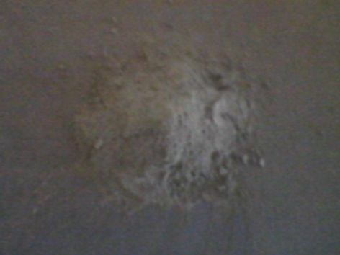
Fig: 4.1.1 Cement
4.2 Aggregates
Aggregates constitute nearly 75% of the total volume of concrete, making them a critical component that significantly influences the mechanical strength, dimensional stability, and durability of the hardened concrete. Well-graded and durable aggregates help in reducing shrinkage, improving workability, and providing a dense and stable matrix. In addition to their role in concrete, aggregates are widely used as base materials in foundations, pavements, and railway tracks due to their strength and load-bearing properties.
For this study, coarse aggregates were employed as per IS: 383–1970 specifications. The aggregates were angular in shape, clean, and free from deleterious materials. The selected grading complied with the requirement that coarse aggregates pass through a 20 mm sieve and are retained on a 12.5 mm sieve. The choice of this size range was made to ensure proper compaction, adequate bonding with the cement paste, and uniform stress distribution within the concrete matrix.
Prior to mixing, the aggregates were tested for key physical properties including specific gravity, bulk density, water absorption, crushing strength, and impact value to ensure conformity with the standards and to assess their suitability for high-strength concrete production.

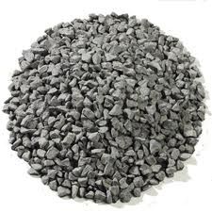
Fig: 4.2.1 Coarse aggregate

4.3 Fine Aggregates
Fine aggregates form the matrix of concrete and fill the voids between coarse aggregates, thereby improving the workability, density, and overall strength of the mix. They play a vital role in reducing segregation and bleeding, while also contributing to the durability and impermeability of hardened concrete. In this study, natural river sand conforming to IS: 383–1970 was used as fine aggregate. The sand was clean, free from organic impurities, clay, and silt. The grading of fine aggregate was such that it passed through a 1.18 mm sieve, ensuring adequate fineness for proper workability and bond development with the cement paste. Tests were carried out on the fine aggregate to determine specific gravity, bulk density, fineness modulus, bulking, and water absorption, in order to ensure compliance with standard requirements and to evaluate its suitability for high-strength concrete.

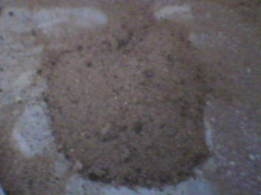

Fig: 4.3.1 Fine aggregate

4.4 Water
Water is a vital component in the concrete mix, performing two primary functions: (i) initiating the hydration process of cement, which leads to hardening and strength development, and (ii) imparting adequate workability to the fresh mix to meet the requirements of placement and compaction. The quality of water used in concrete significantly affects its strength and durability.
For concrete production, the water must be clean, potable, and free from oils, alkalis, acids, salts, sugars, and organic matter, as these impurities may delay setting, reduce strength, or cause premature deterioration of the structure. According to IS: 456–2000, the pH value of water should not be less than 6. In general, acceptable ranges are pH 6.5–8.5 for surface water and pH 6–8.5 for groundwater systems.
In this study, clean potable water conforming to the above requirements was used for both mixing and curing of concrete specimens.
4.5 Rice Husk Ash (RHA)
In addition to the basic ingredients of concrete, Rice Husk Ash (RHA) was incorporated in this study as a supplementary cementitious material. RHA is an agro-industrial by-product obtained from controlled burning of rice husks, which are otherwise considered an environmental nuisance. Owing to its high silica content and amorphous structure, RHA exhibits excellent pozzolanic properties, reacting with calcium hydroxide from cement hydration to form additional calcium silicate hydrate (C–S–H), thereby enhancing strength and durability.
In this project, cement was partially replaced with RHA at replacement levels of 10%, 20%, and 30% by weight of cement. The inclusion of RHA improves several concrete properties such as compressive strength, impermeability, resistance to alkali–silica reaction, and reduction in permeability. Previous studies have shown that RHA can achieve performance comparable to silica fume when properly processed.
Internationally, high-quality RHA has been commercialized, for example, in the United States under the trade name Agro-silica, which is patented and marketed as a high-performance pozzolanic admixture. When used in small proportions (~10% by weight of cement), Agro-silica has been reported to significantly enhance workability, impermeability, and long-term durability. Thus, RHA represents a sustainable and economical alternative to conventional supplementary cementitious materials.

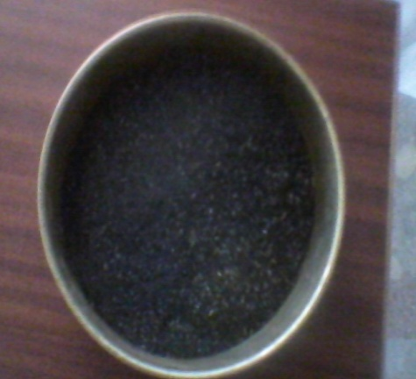
Fig: 4.5.1 Sieved rice husk ash
4.6 RHA Characteristics
Rice Husk Ash (RHA) is obtained as a residual product from open-field burning of rice husks. The material was homogenized and prepared in two conditions for this study:
Natural Rice Husk Ash (NRHA): The ash was dried, homogenized, and packed to facilitate transportation to the laboratory.
Grinded Rice Husk Ash (GRHA): After drying and homogenizing, the RHA was ground in a laboratory ball mill for one hour to optimize fineness.

4.6.1 Physical Properties of RHA
S. No | Particulars | Properties
1 | Colour | Grey
2 | Shape & Texture | Irregular
3 | Mineralogy | Non-crystalline
4 | Particle Size | < 45 micron
5 | Odour | Odourless
6 | Specific Gravity | 1.96

4.6.2 Chemical Properties of RHA
S. No | Particulars | Properties
1 | Silicon Dioxide (SiO₂) | 86.94%
2 | Aluminium Oxide (Al₂O₃) | 0.2%
3 | Iron Oxide (Fe₂O₃) | 0.1%
4 | Calcium Oxide (CaO) | 0.3 – 2.2%
5 | Magnesium Oxide (MgO) | 0.2 – 0.6%
6 | Sodium Oxide (Na₂O) | 0.1 – 0.8%
7 | Potassium Oxide (K₂O) | 2.15 – 2.30%
8 | Loss on Ignition (LOI) | 3.15 – 4.4%

5.TESTING ON PHYSICAL PROPERTIES OF MATERIALS:
5.1 Standard Consistency of Cement
The standard or normal consistency of cement is a critical parameter used to determine the initial setting time, final setting time, soundness, and strength of cement. It is defined as the consistency of a cement paste that allows a Vicat plunger (10 mm diameter, 50 mm length) to penetrate to a depth of 33–35 mm from the top of the mould.
The Vicat apparatus is used to determine the percentage of water required to achieve this consistency. This value is essential for proper mix proportioning and ensuring reliable performance of concrete.
Procedure
- Weigh approximately 300 g of cement and prepare a paste with a measured quantity of water for the first trial.
- Mix the paste thoroughly in a standard manner and fill it into the Vicat mould within 3–5 minutes.
- Gently shake the mould to expel trapped air and ensure uniform compaction.
- Attach the standard Vicat plunger (10 mm diameter, 50 mm length) and lower it to touch the surface of the paste. Release it quickly to allow it to sink under its own weight.
- Record the depth of penetration.
- Repeat the test with increasing water content until the plunger penetrates to 33–35 mm from the top.
- The percentage of water corresponding to this depth is known as the standard consistency of the cement and is usually denoted as ‘p’.

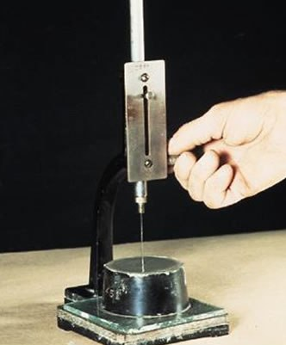
fig: 5.1.1 vicat apparatus
5.1.1.1 FOR 53 GRADE OPC:

Water Content | Initial Reading | Final Reading | Ht. Not Penetrated(mm)
0.28 | 0 | 14 | 14
0.32 | 32 | 6 | 6

Normal consistency of 53 grade OPC cement=32%
5.1.1.2 5 % REPLACEMENT:

Water Content | Initial Reading | Final Reading | Ht. Not Penetrated (mm)
0.25 | 0 | 40 | 40
0.32 | 0 | 19 | 19
0.36 | 0 | 7 | 7

Normal consistency of 95% OPC, 5% RHA = 36%

5.1.3 10 % REPLACEMENT:

water content | initial reading | final reading | Ht.Not penetrated (mm)
0.31 | 0 | 40 | 40
0.40 | 0 | 19 | 19
0.43 | 0 | 7 | 7

Normal consistency of 90% OPC, 10% RHA = 43%

5.1.1.4 15% REPLACEMENT:

Water Content | Initial Reading | Final Reading | Ht. Not  Penetrated (mm)
0.43 | 0 | 20 | 20
0.48 | 0 | 16 | 16
0.53 | 0 | 11 | 11
0.57 | 0 | 6 | 6

Normal consistency of 85% OPC, 15 % RHA = 57%

Fig no: 5.1.2Normal consistency comparison at different replacement values:

5.1.2 Initial and Final Setting Time of Cement
The setting time of cement is a critical property that determines the time available for handling, mixing, and placing concrete. It consists of two parameters:
Initial Setting Time: This is the time elapsed from the moment water is added to cement until the paste starts losing its plasticity. It indicates the period during which cement remains workable. For most cement types, a minimum initial setting time of 30 minutes is recommended to allow proper mixing, transportation, and placement.
Final Setting Time: This is the time elapsed from the addition of water to cement until the paste has completely lost its plasticity and attained sufficient firmness to resist a defined pressure. The final setting time should not exceed 10 hours, ensuring that the cement develops adequate rigidity for structural performance.
Procedure
- Weigh 400 g of cement and gauge it with 0.85 times the water required for standard consistency (0.85p).
- Mix the paste thoroughly and fill it into the Vicat mould within 3–5 minutes. Start the stopwatch immediately when water is added.
- Ensure the temperature of the water and the test room is maintained at 27 ± 2°C during the test.
Determination of Initial Setting Time
- Gently lower the needle of the Vicat apparatus until it touches the surface of the cement paste, then release it to penetrate under its own weight.
- Initially, the needle will fully pierce the paste. As the cement begins to lose plasticity, the needle penetrates only to a depth of 33–35 mm from the top of the mould.
- The time elapsed from the addition of water until the needle penetrates 33–35 mm is recorded as the initial setting time.
Determination of Final Setting Time
- Replace the Vicat needle with the circular attachment.
- Lower the attachment gently onto the surface of the test block.
- The cement is considered finally set when the central needle makes an impression in the paste, but the circular cutting edge does not leave a mark, indicating that the paste has attained sufficient hardness. In other words, the paste has hardened to the point that the central needle penetrates no more than 0.5 mm.
5.1.2.1 FOR 53 GRADE OPC:

Time (mins) | Depth Not Penetrated (mm)
10 | 0
20 | 0
30 | 0.5
35 | 0.5
45 | 1
55 | 1
65 | 2
70 | 5

Initial setting time : 70 mins
Final setting time : 135 mins
5.1.2.2 5 % REPLACEMENT:

Time (mins) | Depth Not Penetrated (mm)
5 | 0
15 | 0
20 | 0
30 | 0
40 | 1
60 | 2.5
75 | 3
85 | 4.5
95 | 5
Initial setting time: 95 mins
Final setting time : 210 mins

5.1.2.310 % REPLACEMENT:

Time (mins) | Depth Not Penetrated (mm)
5 | 0
20 | 0
30 | 0
40 | .5
50 | 1
80 | 2
100 | 3.5
110 | 4
120 | 5

Initial setting time: 120 mins
Final setting time : 300 mins

5.1.2.4 15 % REPLACEMENT:

Time (mins) | Depth Not Penetrated (mm)
10 | 0
20 | 0
40 | 0
60 | .5
70 | .5
80 | 1
95 | 2.5
120 | 3
135 | 4
140 | 4.5
145 | 5

Initial setting time: 145 mins
Final setting time: 390 mins

5.1.3 SPECIFIC GRAVITY OF CEMENT:

The specific gravity is normally defined as the ratio between the weight of a given volume of material and weight of an equal volume of water. To determine the specific gravity of cement, kerosene which does not recent with cement is used.
APPARATUES:
- Le Chatelier’s flask(IS:4031(part 2) 1988)
- Weighing balance.
- Kerosene (free from water).
PROCEDURE:
- Dry the flask carefully and fill with kerosene or naphtha to a point on the stem between zero and 1 ml.
- Record the level of the liquid in the flask as initial reading.
- Put a weighted quantity of cement (about 60 gm) into the flask so that level of kerosene rise to about 22 ml mark, care being taken to avoid splashing and to see that cement does not adhere to the sides of the above the liquid.
- After putting all the cement to the flask, roll the flask gently in an inclined position to expel air until no further air bubble rise3s to the surface of the liquid.
- Note down the new liquid level as final reading.
CALCULATIONS:
- Weight of cement used = 60 gm.
- Initial reading of flask = 0 ml
- Final reading of flask = 23 ml
- Volume of cement particle = 23 ml
- weight of equal of water = 23 x 1000
Specific gravity of cement = (Weight of cement/ Weight of equal volume of water)
= W/(V2-V1)
= 60000/23000
= 2.608

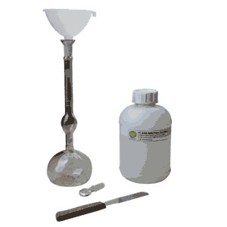

fig: 5.1.3.1 le chatelier”s flask

5.2 TESTS ON AGGREGATES:

5.2.1 SIEVE ANALYSIS AND FINENESS MODULUS OF AGGREGATES:
Fineness modulus is an empirical factor obtained by adding the cumulative percentages of aggregate retained on each of the standard sieves ranging from 80 mm to 150 micron and dividing this sum by 100.
- Fineness modulus is generally used to get an idea of how coarse or fine the aggregate is. More fineness modulus value indicates that the aggregate is coarser and small value of fineness modulus indicates that the aggregate is finer.

5.2.1.1 FINENESS MODULUS OF DIFFERENT TYPE OF SAND IS AS PER GIVEN BELOW:
Type of Sand | Fineness Modulus Range
Fine Sand | 2.2 – 2.6
Medium Sand | 2.6 – 2.9
Coarse Sand | 2.9 – 3.2

- Generally sand having fineness modulus more than 3.2 is not used for making good concrete.
- Fineness modulus can also be used to combine two aggregate to get the desirable grading.

PROCEDURE:
- Sieve the aggregate using the appropriate sieves (80 mm, 40 mm, 20 mm, 10 mm, 4.75 mm, 2.36 mm, 1.18 mm, 600 micron, 300 micron & 150 micron)
- Record the weight of aggregate retained on each sieve.
- Calculate the cumulative weight of aggregate retained on each sieve.
- Calculate the cumulative percentage of aggregate retained.
- Add the cumulative weight of aggregate retained and divide the sum by 100. This value is termed as fineness modulus.
CALCULATION:
Percent retained on each sieve = (Weight of retained sample in each sieve / Total weight of sample).
The cumulative percent retained is calculated by adding percent retained on each sieve as a cumulative procedure.
The percent finer is calculated by subtracting the cumulative percent retained from 100 percent.
5.2.1.2 FINE AGGREGATE:

IS Sieve, (mm) | Wt. Retaine  d (g) | % Retained | Cumulative % Retained | Cumulative % Passed | Zone II
4.75 | 30 | 3.0 | 3.0 | 97.0 | 90 – 100
2.36 | 90 | 9.0 | 12.0 | 88.0 | 75 – 100
1.18 | 285 | 28.50 | 40.50 | 59.50 | 55 – 90
0.6 | 214 | 21.40 | 61.90 | 38.10 | 35 – 59
0.3 | 294 | 28.40 | 91.30 | 8.70 | 8 – 30
0.15 | 70 | 7.0 | 98.30 | 1.70 | 0 – 10
Pan | 17 | 1.70 | 100.0 | – | –
Total wt. = | 1000 |  | 307

Fineness modulus of sand = 307/100 = 3.07

5.2.1.3 COARSE AGGREGATE:

IS Sieve, (mm) | Wt. Retained (g) | % Retained | Cumulative % Retained | Cumulative % Passed | Zone II
40 | 0 | 0 | 0 | 100.0 | 100
20 | 167 | 8.35 | 0.35 | 91.65 | 95 – 100
10 | 1295 | 64.75 | 73.10 | 26.90 | 25 – 55
4.75 | 527 | 26.35 | 99.45 | 0.55 | 0 – 10
Pan | 11 | 0.55 | 100.0 | – | –
Total wt. = | 2000 |  | 281

Fineness modulus of coarse aggregate = 281/100 = 2.81

5.2.2 BULK DENSITY OF AGGREGATES:
This test method is often used to determine bulk density values that are necessary to use for many methods of selecting proportions for concrete mixtures. The bulk density also may be used for determining mass/volume relationships for conversions in purchase agreements.

A. PROCEDURE FOR COMPACTED BULK DENSITY:
- Measure the volume of the cylindrical metal measure by pouring water into the metal measure and record the volume “V” in litre.
- Fill the cylindrical metal measure about one-third full with thoroughly mixed aggregate and tamp it 25 times using tamping bar.
- Add another layer of one-third volume of aggregate in the metal measure and give another 25 strokes of tamping bar.
- Finally fill aggregate in the metal measure to over-flowing and tamp it 25 times.
- Remove the surplus aggregate using the tamping rod as a straightedge.
- Determine the weight of the aggregate in the measure and record that weight “W” in kg.

B. PROCEDURE FOR LOOSE BULK DENSITY:
- Measure the volume of the cylindrical metal measure by pouring water into the metal measure and record the volume “V” in litre.
- Fill the cylindrical measure to overflowing by means of a shovel or scoop, the aggregate being discharged from a height not exceeding 5 cm above the top of the measure
- Level the top surface of the aggregate in the metal measure, with a straightedge or tamping bar.
- Determine the weight of the aggregate in the measure and record the weight “W” in kg.

CALCULATION:
Bulk density = W/V
Where,
W = Weight of loose aggregate in cylindrical metal measure, kg
V = Volume of cylindrical metal measure, litre
5.2.2.1 BULK DENSITY OF AGGREGATES:
Sample State | Sample Type | Wt. of Container (kg) | Volume of Container (m³) | Wt. of Container + wt. of Aggregate (kg) | Wt. of Aggregate (kg) | Bulk density (kg/m³)
loose | Fine | 5.7 | 0.0035 | 10.60 | 4.9 | 1400
loose | Coarse | 7.45 | 0.0053 | 15.3 | 7.85 | 1481
compacted | Fine | 5.7 | 0.0035 | 11.15 | 5.45 | 1557
compacted | Coarse | 7.45 | 0.0053 | 16.20 | 8.75 | 1651

5.2.3 SPECIFIC GRAVITY OF AGGREGATES:

OBJECTIVE:
For determination of specific gravity of sand and Coarse aggregate by pycnometer method.( IS: 2720 (Part 4) – 1985).
EQUIPMENT & APPARATUS:
- Pycnometer
- Sieve(4.75 mm)
- Vaccum pump
- Oven
- Weighing balance
- Glass rod

PROCEDURE:
- Dry the Pycnometer and weigh it with its cap(W₁)
- Take about 200 g to 300 g of oven dried soil passing through 4.75mm sieve into the Pycnometer and weigh again(W₂)
- Add water to cover the soil and screw on the cap.
- Shake the Pycnometer well and connect it to the Vaccum pump to remove entrapped air for about 10 to 20 minutes.
- After the air has been removed, fill the Pycnometer with water and weigh it (W₃).
- Clean the Pycnometer by washing thoroughly.
- Fill the cleaned Pycnometer completely with water upto its top with cap screw on.
- Weigh the Pycnometer after drying it on the outside thoroughly (W₄).
- Similarly, repeat the steps for coarse aggregate.
CALCULATIONS:

FINE AGGREGATE:
Weight of empty pycnometer (m1) : 458.10g
Weight of pycnometer + sand (m2) : 676g
Weight of pycnometer + sand + water (m3) : 1390g
Weight of pycnometer +water (m4) : 1253g
Specific gravity of fine aggregate: m2-m1 / (m2-m1)-(m4-m3)
= 2.693
Specific gravity of fine aggregate = 2.693

COARSE AGGREGATE:
Weight of empty pycnometer (m1) : 458g
Weight of pycnometer + aggregate (m2) : 706g
Weight of pycnometer + aggregate + water (m3) : 1405g
Weight of pycnometer +water (m4) : 1258g
Specific gravity of coarse aggregate = m2-m1 / (m2-m1)-(m4-m3)
= 2.45
Specific gravity of coarse aggregate = 2.45

5.2.4WATER ABSORPTION TEST (IS 2386):
Water absorption gives an idea of strength of aggregates. Aggregates having more water absorption are more porous in nature and are generally considered unsuitable unless they are found to be acceptable based on strength, Impact and hardness test.

EQUIPMENT & APPARATUS:
- Wire basket
- Oven (300⁰c)
- Container for filling water and suspending the basket
- An air tight container
- Balance[0-10 kg]
- Shallow tray & absorbent clothes

PROCEDURE:
- About 2kg of the aggregate sample is washed thoroughly to remove fines, drained and then placed in the wire basket and immersed in distilled water at a temperature between 22 to 32⁰C with a cover of at least 50 mm of water above the top of the basket
- Immediately after the immersion the entrapped air is removed from the sample by lifting the basket containing it 25 mm above the base of the tank and allowing it to drop 25 times at the rate of about one drop per second. The basket and the aggregate should remain completely immersed in water for a period of 24±0.5 hours afterwards.
- The basket and the sample are then weighed while suspended in water at a temperature of 22 to 32⁰C. The weight is noted while suspended in water (W₁) g.
- The basket and the aggregate are then removed from water and allowed to drain for a few minutes, after which the aggregates are transferred to one of the dry absorbent clothes.
- The empty basket is then returned to the tank of water, jolted 25 times and weights in water (W₂) g.
- The aggregates placed in the dry absorbent clothes are surface dried till no further moisture could be removed by this clothe.
- Then the aggregate is transferred to the second dry cloth spread in a single layer, covered and allowed to dry for at least 10 minutes until the aggregates are completely surface dry. 10 to 60 minutes drying may be needed. The surface dried aggregate is then weighed W₃g.
- The aggregate is placed in a shallow tray and kept in an oven maintained at a temperature of 110⁰C for 24 hours. It is then removed from the oven, cooled in air tight container and weighed W₄ g.
CALCULATION:
Water absorption = (W₃ – W₄)*100/W₄
Water absorption of fine aggregate = 1.12 %
Water absorption of coarse aggregate = 0.58 %

5.2.5 BULKING OF FINE AGGREGATE:
The volume increase of fine aggregate due to presence of moisture content is known as bulking. Fine sand bulks more as compared to coarse sand. Extremely fine sand particularly the manufactured fine aggregate bulks as much as about 40%.
Note: Fine aggregate do not show any bulking when it is absolutely dry or completely saturated.
The moisture present in aggregate forms a film around each particle. These films of moisture exert a force, known as surface tension, on each particle. Due to this surface tension each particles gets away from each other. Because of this no direct contact is possible among individual particles and this causes bulking of the volume.
Bulking of aggregate is dependent upon two factors,
- Percentage of moisture content
- Particle size of fine aggregate
Bulking increases with increase in moisture content upto a certain limit and beyond that the further increase in moisture content results in decrease in volume. When the fine aggregate is completely saturated it does not show any bulking. Fine sand bulks more as compared to coarse sand, i.e. percentage of bulking in indirectly proportional to the size of particle.
Due to bulking, fine aggregate shows completely unrealistic volume. Therefore, it is absolutely necessary that consideration must be given to the effect of bulking in proportioning the concrete by volume. If care is not given to the effect of bulking, in the case of volume batching, the resulting concrete is likely to be understand and harsh. It will also affect the yield of concrete for a given cement content.
PROCEDURE:
The extent of bulking can be estimated by a simple field test.
- Fill a sample of moist fine aggregate (sand) into a measuring cylinder in the normal manner. Note down the level, say h₁.
- Pour water into a measuring cylinder and completely cover the sand with water and shake it. Since the volume of the saturated sand is the same as that of the dry sand, the saturated sand completely offsets the bulking effect. Note down the level of sand, say h₂.
- Subtract the final level h2 from initial level h1 (i.e. h₁-h₂), which shows the bulking of sand under test.
- Percentage of bulking = [(h₁-h₂)/h₂]*100
CALCULATION:
Percentage of bulking = [(h₁-h₂)/h₂]*100
= [(50 – 47.7)/47.7]*100
= 4.82%

5.2.6 CRUSHING STRENGTH OF AGGREGATE:

OBJECTIVE:
For determination of the aggregate crushing value of coarse aggregate, which passes 12.5 mm. IS sieve and retained on 10 mm. IS sieve.( IS: 2386 (Part IV)-1963).

EQUIPMENT & APPARATUS:
- Steel Cylinder
- Sieves (12.5mm,10mm)
- Cylindrical metal measure
- Tamping Rod
- Balance (0-10kg)
- Oven (300⁰c)
- Compression testing Machine (2000KN)

PROCEDURE:
- The cylindrical steel cup is filled with 3 equal layers of aggregate and each layer is tamped 25 strokes by the rounded end of tamping rod and the surplus aggregate struck off, using the tamping rod as a straight edge.
- The net weight of aggregate in the cylindrical steel cup is determined to the nearest gram (W_{A}) and this weight of aggregate is used for the duplicate test on the same material.
- The cup is fixed firmly in position on the base of the machine and the whole of the test sample is added in thirds, each third being subjected to 25stokes from tamping rod.
- The surface is levelled and the plunger is inserted so that it rests horizontally on the surface. The whole assembly is then placed between the platens of testing machine and loaded at a uniform rate so as to reach a load of 40 tones in 10 minutes.
- The load is then released and all aggregate is removed from the cup and sieved on 2.36 mm. IS sieve until no further significant amount passes in one minute.
- The fraction passing the sieve is weighed to an accuracy of 0.1 g (W_{B})

CALCULATION:
Aggregate crushing Value = (W_{B}/W_{A}) × 100
= 10.91 %

5.2.7IMPACT VALUE OF AGGREGATE:

OBJECTIVE:
For determination of the aggregate impact value of coarse aggregate, which passes 12.5 mm. IS sieve and retained on 10 mm. IS sieve.

REFERENCE STANDARDS:
IS: 2386(Part IV)-1963 Methods of test for aggregate for concrete Part IV Mechanical Properties.

EQUIPMENT & APPARATUS:
- Aggregate Impact Test Machine
- Sieves (12.5mm,10mm)
- Cylindrical metal measure
- Tamping Rod
- Balance (0-10kg)
- Oven(300⁰c)

PROCEDURE:
- The cylindrical steel cup is filled with 3 equal layers of aggregate and each layer is tamped 25 strokes by the rounded end of tamping rod and the surplus aggregate struck off, using the tamping rod as a straight edge.
- The net weight of aggregate in the cylindrical steel cup is determined to the nearest gram (W_{A}) and this weight of aggregate is used for the duplicate test on the same material.
- The cup is fixed firmly in position on the base of the machine and the whole of the test sample is placed in it and compacted by a single tamping of 25 strokes of tamping rod.
- The hammer is raised until its lower face is 380 mm. above the upper surface of the aggregate in the cup, and allowed to fall freely onto the aggregate 15 times, each being delivered at an interval of not less than one second.
- The crushed aggregate is removed from the cup and sieved on 2.36 mm. IS sieve until no further significant amount passes in one minute.
- The fraction passing the sieve is weighed to an accuracy of 0.1 g (W_{B}).

CALCULATION:
Aggregate impact Value = (W_{B} / W_{A}) × 100
= 14.63 %
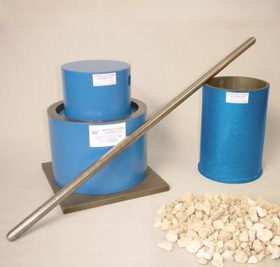
fig: 5.2.6aggregate crushing test apparatus
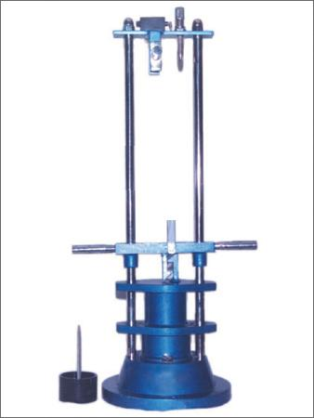
fig: 5.2.7 aggregate impact testing apparatus

5.3RICE HUSK ASH (RHA) PROPERTIES:
5.3.1SPECIFIC GRAVITY OF RHA:
Specific gravity of a material is essential to assess different properties of a material.,
Weight of empty pycnometer (m1) : 458g
Weight of pycnometer + rice husk ash (m2) : 590g
Weight of pycnometer + RHA + water (m3) : 1359g
Weight of pycnometer +water (m4) : 1292g

Specific gravity of RHA = m2-m1 / (m2-m1)-(m4-m3)
= 0.663
Specific gravity of RHA = 0.663

5.3.2 FINENESS OF RHA:

Take 100 grams of cement and sieve through IS 9 sieve.
Mass of sample of RHA : 100g
Mass passing 90 micron sieve : 14g
Fineness of RHA = 86%

6.TESTING ON FRESH CONCRTE

6.1 WORKABILITY:
Workability is defined as the property of concrete which determines the amount of useful internal work necessary to produce full compaction. Hundred percent compaction of concrete is an important parameter for contributing to the maximum strength. Lack of compaction will result in air voids whose damaging effect on strength and durability.

FACTORS AFFECTING WORKABILITY:
Workable concrete is the one which exhibits very little internal friction between particle and particle or which overcomes the frictional resistance offered by the formwork surface or reinforcement contained in the concrete with just the amount of compacting efforts.
The factors which are affecting the workability of concrete are:-
- Water content
- Shape of aggregates
- Size of aggregates
- Surface texture of aggregates
- Grading of aggregates
- Mix proportions
- Use of admixtures.

6.1.1 SLUMP TEST:
Slump test is the most commonly used method of workability of concrete which can be employed either in laboratory or at site of work.
The apparatus for conducting the slump test is essentially consists of a
- Metallic mould in the form of a frustum of a cone having the internal dimensions as

- Bottom diameter : 20 cm
- Top diameter : 10 cm
- Height : 30 cm
- A steel tamping rod

- Diameter :16 mm
- Length : 0.6 m with a bullet end.

PROCEDURE:

- The internal surface of the mould is thoroughly cleaned and freed from superfluous moisture and adherence of any oldest concrete before commencing the test.
- The mould is placed on a smooth, horizontal, rigid and non-absorbent surface.
- The mould is then filled in four layers, each approximately ¼ of the height of the mould.
- Each layer is tamped 25 times by the tamping rod taking care to distribute the strokes evenly over the cross section.
- After the top layer has been rodded, the concrete is stuck off level with a trowel and tamping rod.
- The mould is removed from the concrete immediately by raising it slowly and carefully in a vertical direction. This allows the concrete to subside. The subsidence is referred to as SLUMP of concrete.
- The difference in level between the height of the mould and that of the highest point of the subsided concrete is measured. This difference in height is noted in mm and is taken as Slump of concrete.
- Higher the slump value, higher is the workability.
- The mix we prepared for testing was of M25.

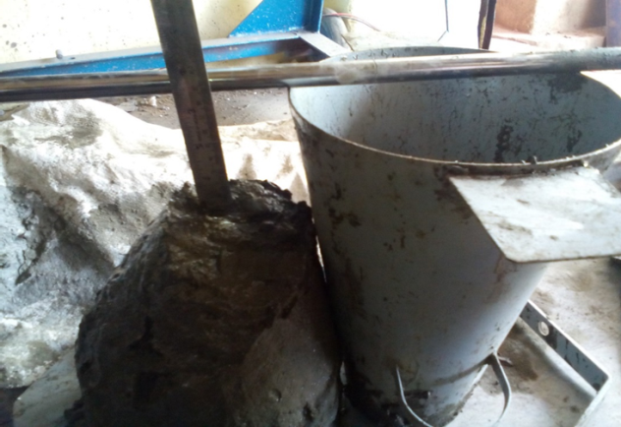

Fig 6.1.1 Slump cone test

TABLE 6.1.1.1

0-25mm slump | Low workability
25-75mm slump | Medium workability
75-100mm slump | High workability

6.1.1.2 SLUMP VALUE AT DIFFERENT REPLACEMENT % OF RHA:
% REPLACEMENT | WATER CONTENT % | SLUMP (mm)
0 | 0.50 | 95
5 | 0.50 | 92
10 | 0.50 | 80
15 | 0.50 | 46

Fig no: 6.1.2Slump comparision at different replacement values
Workability of the mix reduces greatly as the percentage replacement of RHA increases

7. TESTING ON HARDENED CONCRETE
7.1 COMPRESSIVE STRENGTH TEST:
The compressive strength of concrete is one of the most important and useful properties of concrete. In most structural applications concrete is employed primarily to resist compressive stresses. The concrete making properties of various ingredients of mix are usually measured in terms of the compressive strength. Compressive strength is also used as a qualitative measure for other properties of hardened concrete.
The mix we prepared for testing was of M25.

PROCEDURE:
- For the preparation of the specimens the following procedure is adopted and this module includes the curing of the Cubes and is illustrated as follows.
- Weigh the quantities of cement, fine Aggregates, Coarse Aggregates and water for one batch of concrete to an accuracy of 0.1% of the total weight of batch.
- Mix the concrete by hand (or) preferably in a laboratory batch mixer.
- For mixing the Concrete we have adopted the standard mix ratio 1:1:2.
- First of all mix the equal amounts of Cement and sand with hand followed by the trowel.
- Now add the coarse aggregates to the cement and sand and mix it thoroughly. Mixing should be in such a way that all the constituents in the concrete should mix uniformly so that we can obtain a uniform mix.
- Now add 0.5 % of water by the weight of cement to the Mix. Care should be taken water should not go out of the mixing plate.
- Mix the concrete after adding the water thoroughly.
- Now take the moulds of size 10x10x10 cms, apply grease or oil to the sides of the mould. Make sure that the screws are fixed tightly so that bleeding does not take place.
- Now transfer the required quantity of the concrete into the moulds. Transfer of concrete should be in such a way that we should lay nearly 4 layers and compacting each layer for 25 times.
- After filling the mould level it on the top side of the cube and leave it aside for 24 Hours.
- After 24 hours unfasten the screws and take out the cube and proceed for curing.
- We have adopted the method of Immersion for curing. The cubes are to be placed in the water for 7 days, 21 days, 28 days and compression test is to be done with respect to the age.
- Care should be taken that the specimens are deeply immersed in the water and the water should be free from the organic matter, salinity, and alkalinity of higher order as it affect the durability of the concrete.
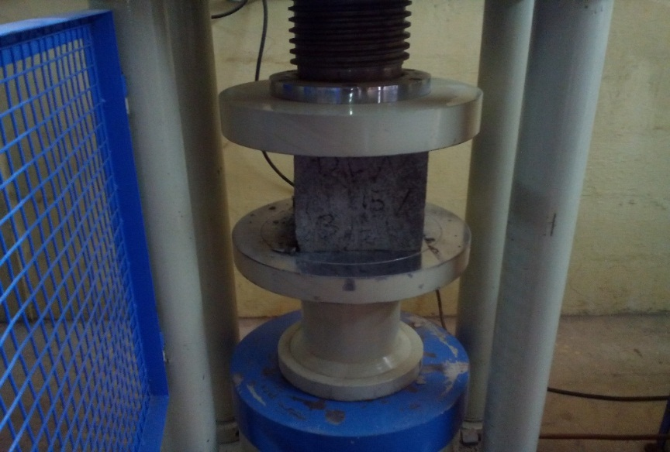
fig: 7.1.1 compression testing on cube
FACTORS AFFECTING STRENGTH OF CONCRETE:
- Ratio of cement to water mixing
- Ratio of cement to aggregate
- Grading, surface texture, shape, strength and stiffness of aggregate particles
- Maximum size of aggregate

7.1.1.1 COMPRESSIVE STRENGTH OF CONCRETE AT DIFFERENT REPLACEMENTS % OF RHA:
% of replacement | 7 days  N/mm2 | 14 days  N/mm2 | 28 days  N/mm2
No replacement | 24.2 | 29.30 | 34.90
5% replacement | 28.10 | 38.20 | 40.8
10% replacement | 24.8 | 28.20 | 34.10
15% replacement | 17.20 | 19.10 | 24.9

fig no: 7.1.2 compressive strength for different % of RHA

7.2 SPLIT TENSILE STRENGTH TEST:
The tensile strength is one of the basic and important properties of the concrete. The concrete is not usually expected to resist the direct tension because of its low tensile strength and brittle nature. However, the determination of tensile strength of concrete is necessary to determine the load at which the concrete members may crack. The cracking is a form of tension failure.
The mix we prepared for testing was of M25.

PROCEDURE:
For the preparation of the specimens the following procedure is adopted and this module includes the curing of the Cylinders and is illustrated as follows.
- Weigh the quantities of cement, fine Aggregates, Coarse Aggregates and water for one batch
- Mix the concrete by of concrete to an accuracy of 0.1% of the total weight of batch. Hand (or) preferably in a laboratory batch mixer.
- For mixing the Concrete we have adopted the standard mix ratio 1:1:2.
- First of all mix the equal amounts of Cement and sand with hand followed by the trowel.
- Now add the coarse aggregates to the cement and sand and mix it thoroughly. Mixing should be in such a way that all the constituents in the concrete should mix uniformly so that we can obtain a uniform mix.
- Now add 0.5 % of water by the weight of cement to the Mix. Care should be taken water should not go out of the mixing plate.
- Mix the concrete after adding the water thoroughly.
- Now take the moulds of size 10 cm dia. x 20 cm length, apply grease or oil to the sides of the mould. Make sure that the screws are fixed tightly so that bleeding does not take place.
- Now transfer the required quantity of the concrete into the moulds. Transfer of concrete should be in such a way that we should lay nearly 4 layers and compacting each layer for 25 times.
- After filling the mould level it on the top side of the cylinder and leave it aside for 24 Hours.
- After 24 hours unfasten the screws and take out the cylinder and proceed for curing.
- We have adopted the method of Immersion for curing. The cylinders are to be placed in the water for 28 days and test is to be done with respect to the age.
- Care should be taken that the specimens are deeply immersed in the water and the water should be free from the organic matter, salinity, and alkalinity of higher order as it affect the durability of the concrete

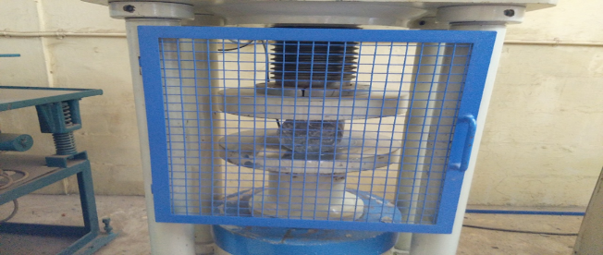
7.2.1.1 SPLIT TENSILE STRENGTH OF CONCRETE WITH DIFFERENT REPLACEMENT % OF RHA:

Mix | Dia. Of Specimen (mm) | Length Of Specimen (mm) | Splitting Strength (MPA)
Normal mix | 100 | 200 | 3.24
5 % RHA | 100 | 200 | 3.81
10% RHA | 100 | 200 | 3.19
15% RHA | 100 | 200 | 2.70

fig: 7.2.1 split tensile strength test on cylinder

fig no: 7.2.2 split tensile strength of concrete at different replacement % of RHA at 28 days

7.3 FLEXURAL STRENGTH TEST:

Flexural Strength of Concrete, which comes into play when a road slab with inadequate sub-grade support is subjected to wheel loads and / or there are volume changes due to temperature / shrinking. (IS: 516-1959 – Methods of tests for strength of concrete).Flexural strength, also known as modulus of rupture, bend strength, or fracture strength, a mechanical parameter for brittle material, is defined as a material's ability to resist deformation under load. The transverse bending test is most frequently employed, in which a specimen having either a circular or rectangular cross-section is bent until fracture or yielding using a three point flexural test technique. The flexural strength represents the highest stress experienced within the material at its moment of rupture. It is measured in terms of stress, here given the symbol.

PROCEDURE:
- Test specimens shall be prepared by mouldings concrete to a beam section, curing and storing in accordance with standard procedure. The section of the beam shall be square of 100 mm or 150 mm. The overall length of the specimen shall be 4d to 5d. The ratio of d to the maximum particle size of aggregate shall be not less than three.
- Circular rollers manufactured out of steel having cross section with diameter 38 mm will be used for providing support and loading points to the specimens. The length of the rollers shall be at least 10 mm more than the width of the test specimen. A total of four rollers shall be used, three out of which shall be capable of rotating along their own axes. The distance between the outer rollers (i.e. span) shall be 3D and the distance between the inner rollers shall be D. The inner rollers shall be equally spaced between the outer rollers, such that the entire system is systematic.
- The specimen stored in water shall be tested immediately on removal from water; whilst they are still wet. The test specimen shall be placed in the machine correctly centered with the longitudinal axis of the specimen at right angles to the rollers. For moulded specimens, the mould filling direction shall be normal to the direction of loading.
- The load shall be applied slowly without shock at such a rate as to increase the stress at a rate of .06 + .04 N/mm² per second.

7.3.1.1 FLEXURAL STRENGTH OF CONCRETE AT DIFFERENT REPLACEMENT % OF RHA:
Mix | Flexural Strength (MPA)
Normal mix | 4.31
5 % RHA | 4.62
10% RHA | 4.16
15% RHA | 3.76
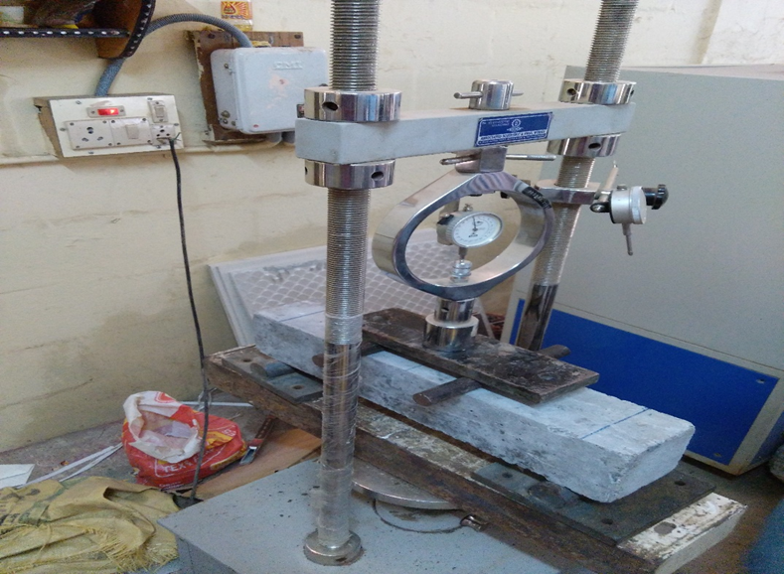
fig: 7.3.1 flexural strength test on concrete beam

fig no:7.3.3 flexural strength of concrete at different replacement % of RHA at 28 days
8.ADVANTAGES OF USING RICE HUSK ASH IN CONCRETE
The partial replacement of cement with Rice Husk Ash (RHA) offers several technical, economic, and environmental benefits:
- Economic Feasibility: Replacing cement with RHA reduces the overall cost of concrete production.
- Waste Utilization: Disposal costs for rice husk are eliminated, converting an agricultural by-product into a valuable construction material.
- Compatibility: RHA does not adversely react with other constituents of concrete, maintaining material stability.
- Enhanced Strength: Compressive strength of concrete is improved, particularly at 10% cement replacement, due to the pozzolanic reaction.
- Environmental Sustainability: Rice husk is abundantly available as waste. Its use in concrete production reduces environmental pollution and waste accumulation.
- Improved Durability: The inclusion of RHA enhances impermeability, reduces thermal cracking, and contributes to long-term durability while slightly decreasing construction costs.
- Workability and Stability: RHA improves workability, reduces heat evolution, and minimizes plastic shrinkage, making concrete easier to handle and compact.
- Reduction of Alkali-Aggregate Reaction: The micro-porous structure of RHA refines the pore network, hinders diffusion of alkali ions, reduces expansion, and minimizes deleterious alkali-aggregate reactions.
Summary: Incorporating RHA into concrete not only improves structural performance but also promotes sustainable and eco-friendly construction practices, making it a practical choice for modern high-strength concrete applications.

- CONCLUSION
This study investigated the partial replacement of cement with Rice Husk Ash (RHA) in high-strength concrete, focusing on its effects on both fresh and hardened concrete properties. The aim was to explore a sustainable and economical alternative to conventional cement by utilizing an agro-industrial by-product, thereby reducing environmental impact while maintaining or enhancing concrete performance.
From the experimental investigation, it was observed that the incorporation of RHA significantly influences the mechanical and physical characteristics of concrete. Among the various replacement levels tested (10%, 20%, and 30%), the 10% replacement of cement with RHA demonstrated the most favorable balance between strength development and workability. At this level, the compressive strength of concrete showed noticeable improvement compared to the control mix, indicating that RHA contributes positively to the formation of additional calcium silicate hydrate (C–S–H) through its pozzolanic reaction, thereby enhancing the structural integrity of the concrete. While higher replacement levels (20% and 30%) further increased the silica content, they negatively impacted workability, resulting in a harsher mix that is more difficult to handle and compact. The standard consistency and initial/final setting times of the cement paste were also influenced by RHA incorporation, highlighting the need for careful proportioning to maintain practical usability in construction applications.
Optimal Replacement Recommendation: The study concludes that a 10% replacement of cement with RHA is the most practical and adoptable mix. This level achieves a desirable combination of improved strength, adequate workability, and environmental sustainability, making it suitable for high-strength concrete applications in both conventional and low-cost construction projects.
Note: Among all replacement percentages tested, 10% RHA replacement is the most adoptable due to:
- Significant increase in compressive strength.
- Satisfactory workability of the concrete mix.
- Minimal negative impact on cement consistency and setting times.
In conclusion, RHA proves to be a viable supplementary cementitious material, with the potential to enhance concrete performance while promoting sustainable construction practices. Future studies could explore long-term durability, durability under aggressive environmental conditions, and integration with other supplementary materials to further optimize concrete mixes for structural applications.

10.REFERENCES
[1] M. S. Shetty, A Text Book of Concrete Technology, S. Chand Publishing, 2005.
[2] Bronzeoak Ltd, Rice Husk Ash Market Study, ETSU U/00/00061/REP DTI/Pub URN 03/668, 2003.
[3] S. Chandra, Waste Materials Used in Concrete Manufacturing, William Andrew Inc., Norwich, NY, 2002.
[4] C. L. Hwang and D. S. Wu, "Properties of Cement Paste Containing Rice Husk Ash," ACI SP-114, 1989.
[5] I. I. Dashan and E. E. I. Kamang, "Some characteristics of RHA/OPC Concretes: A Preliminary Assessment," Nigerian Journal of Construction Technology and Management, vol. 2, no. 1, pp. 22–28, 1999.
[6] M. K. O., Rice Husk as Stabilizing Agents in Clay Bricks, Higher National Diploma Project, Department of Civil Engineering, Federal Polytechnic Bida, Nigeria, 1994.
[7] G. Y. Mbiminah, Effects of Rice Husk on the Comprehensive Strength and Durability of Burnt-Clay Bricks, B. Eng. Project, Department of Civil Engineering, Ahmadu Bello University Zaria, Nigeria, 1992.
[8] M. N. Al-Khalaf and H. A. Yousif, "Use of Rice Husk Ash in Concrete," International Journal of Cement Composites and Lightweight Concrete, vol. 6, no. 4, pp. 241–248, 1984.
[9] Ismail and Waliuddin, "Effect of rice husk ash on high strength concrete," Construction and Building Material, vol. 10, no. 7, pp. 521–526, 1996.
[10] G. A. Akeke, M. E. Ephraim, I. Z. S. Akobo, and J. O. Ukpata, "Structural Properties of Rice Husk Ash Concrete," International Journal of Engineering and Applied Sciences, vol. 3, no. 3, May 2013.
[11] J. Rajput, R. K. Yadav, and R. Chandak, "The Effect of Rice Husk Ash Used as Supplementary Cementing Material on Strength of Mortar," International Journal of Engineering Research and Applications (IJERA), vol. 3, no. 3, pp. 133–136, May-Jun 2013.
[12] A. K. Al-Alwan, "The impact of using rice husk ash as a replacement material in concrete," 2024.
[13] E. Khankhaje, "Utilizing rice husk ash as cement replacement in pervious concrete," 2025.
[14] S. A. Endale, "Rice Husk Ash in Concrete," MDPI Sustainability, vol. 15, no. 1, p. 137, 2022.
[15] M. Valenzuela, "Designing sustainable cement-free compositions with rice husk ash," Scientific Reports, vol. 15, no. 1, p. 97963, 2025.
[16] H. M. Hamada, "Impact of rice husk ash on geopolymer concrete," 2025.
[17] S. Barbhuiya, "Rice husk ash in structural concrete: influence on strength and durability," 2025.
[18] M. N. Amin, "Mapping Research Knowledge on Rice Husk Ash," 2022.
[19] C. Li, "Compressive Strength Prediction of Rice Husk Ash Concrete," 2023.
[20] Y. Li, "Impact of Rice Husk Ash Properties on Concrete Strength," 2025.
[21] O. Zaid, "Effect of Incorporation of Rice Husk Ash Instead of Cement," 2021.
[22] Y. Jing, "Durability and environmental evaluation of rice husk ash concrete," Scientific Reports, vol. 15, no. 1, p. 88927, 2025.
[23] S. P. M. Pérez, "Use of recycled concrete and rice husk ash for concrete," 2023.
[24] Z. Guo, "The Influence of Rice Husk Ash Incorporation on Concrete Properties," MDPI Materials, vol. 18, no. 2, p. 460, 2025.
[25] G. Rodriguez de Sensale, "Role of Concrete in Sustainable Development," Theme Three: Durability and Performance, pp. 255–264, 2003.
[26] Ramezanianpour et al., "Rice husk ash characteristics from controlled burning," 2009–2010.
[27] Al Khalaf and A. Yousif, "Use of Rice Husk Ash in Concrete," International Journal of Cement Composites and Lightweight Concrete, vol. 6, Nov. 1984.
[28] Ismail and Waliuddin, "Effect of rice husk ash on high strength concrete," Construction and Building Material, vol. 10, no. 7, 1996, pp. 521–526.
[29] Jayanti Rajput, R. K. Yadav, R. Chandak, "The Effect of Rice Husk Ash on Strength of Mortar," International Journal of Engineering Research and Applications, vol. 3, no. 3, 2013, pp. 133–136.
[30] Godwin A. Akeke, M. E. Ephraim, I. Z. S. Akobo, and J. O. Ukpata, "Structural Properties of Rice Husk Ash Concrete," International Journal of Engineering and Applied Sciences, vol. 3, no. 3, May 2013.

11.BIBLOGRAPHY
For the successful completion this project we have referred many book in the internet and we have downloaded many IS Codes related and required to our project. We have referred many sites for getting the clear idea about the project which we have proposed and the reference sites are as follows.

- http://en.wikipedia.org/wiki/
- www.google.com
- www.books.google.co.in/
- www.scribd.com
- www.faadooengineers.com

